
Portfolio of legal affairs
Cayman Islands Government
4th Floor, Government Administration Building, 133 Elgin Avenue, Cayman Islands

Job Description

Job Title: Crown Counsel (Civil)
Grade: H
Salary Range: CI$81,252 to CI$109,296
Reports To: Solicitor General
Cost Centre: 0903 Solicitor General

Job Purpose | To undertake civil litigation and to provide legal advice and assistance to Government Ministries, Departments and statutory authorities.
Dimensions | The post holder will be required to assist with the provision of legal advice and the conduct of civil litigation in relation to a wide range of matters relevant to the work of the Solicitor General’s Office (SGO) on behalf of the Attorney General including but not limited to administrative/public law, human rights, constitutional law, immigration, tort, employment, matters arising under the Children Law, freedom of information and data protection, planning, land law, the preparation and review of contracts and other legal agreements and procurement.  The civil work of the SGO is likely to involve an average of 10 major legal court actions as well as a number of less complex cases per year. Approximately 350 requests for advice are reviewed and 40 agreements of varying complexity will be prepared or reviewed during the course of a year.
 | Under the general supervision of the Solicitor General, the post-holder will:
Principal Accountabilities | - Have general conduct of civil litigation before all tiers of the Courts of the Cayman Islands (including matters arising under the Children Act and Mental Health Act) and tribunal proceedings.  - Provide legal advice and assistance to various Government Ministries, Departments, statutory authorities and boards.  - Draft contracts, memoranda of understanding, agreements and other legal instruments, including if required, being involved in any negotiation process leading up to the preparation of such contracts/agreements.  - Represent the SGO on boards and committees as and when required by the Solicitor General.  - Supervise Articled Clerks and Crown Counsel II.  - Carry out such other related duties as may be allocated by the Attorney General or Solicitor General from time to time.

Organisational Chart
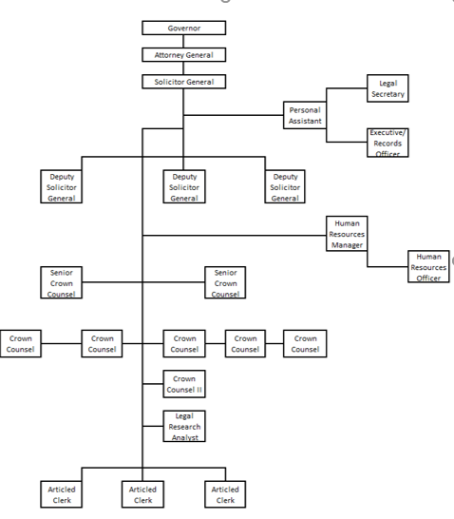

Background Information | The Cayman Islands is a British Overseas Territory with a legal system based on that of England. The common law applies, as modified by locally enacted Laws. There is a unified legal profession.  The SGO is responsible for the day-to-day conduct of civil litigation to which the Government is a party and provision of legal advice to Government Ministries, departments and statutory authorities. It sits within the Portfolio of Legal Affairs, headed by the Attorney General, the principal legal advisor to the Government and head of the local bar. The Portfolio includes the Law Reform Commission, Law Revision Commission, Legislative Drafting Department, Financial Reporting Authority, Anti-Money Laundering Unit and the Truman Bodden Law School.  There are three tiers of courts. The Summary Courts, presided over by magistrates, have both criminal and civil jurisdiction. Appeals are at the Grand Court, which also has an original jurisdiction similar to that of the English High Court of Justice in all its divisions. There is a Chief Justice and six Puisne Judges. Appeals are the Court of Appeals, comprised of distinguished jurists from the wider Caribbean, and thence to the Privy Council in London.
Knowledge, Experience, and Skills |  | Knowledge/Qualifications:  A Solicitor, Barrister or Attorney-at-Law and qualified to practice in an English-speaking Commonwealth jurisdiction.  Experience:  At least five (5) years relevant post-qualification experience.  Knowledge of and experience with all aspects of litigation practice and procedure including the preparation of pleadings, affidavits and the drafting of legal submissions.  Skills:  Sound advocacy skills and litigation experience.  Strong verbal and written communication skills.  The ability to assimilate instructions quickly, conduct independent research and provide comprehensive, reliable, and timely legal advice to all organs of Government.  The ability to work independently while managing the allocated case portfolio as well as part of a team as and when required.  Effective working knowledge of Microsoft Word, Excel, PowerPoint and Outlook.
Assignment and Planning of Work |  | Work is generated by the Cabinet, Government Ministries, Departments, and statutory authorities. It is allocated by the Solicitor General and or Deputy Solicitor General and the post holder works under their general supervision. Deadlines are set by the Solicitor General and/or Deputy Solicitor General having regard to the needs of the client entity and in accordance with the Grand Court Rules and relevant laws.
Supervision of Others |  | The post holder is required to supervise the work of Articled Clerks within the SGO.
Other Working Relationships |  | Liaison with Government Ministries, departments and statutory authorities and the Courts Office.
Decision Making Authority and Controls |  | The post holder will work in accordance with the requirements of the Public Service Management Act and Personnel Regulations, Grand Court Rules and departmental instructions/policies.
Problems/Key Features |  | A significant caseload, at times involving complex legal issues and strict deadlines.
Working Conditions |  | Normal Office Conditions apply to this post.

 | Signatures: | Date:
Head of Department
Job Holder

